PRN: 2019BTECS00043

NAME: Mali Krushna

**Practical No. 4: To install and configure a Web Server.**

**Problem Statement 1:**

1. **Install a web server on your machine. Run the server locally.**

**ANS:**

1. **Download –**

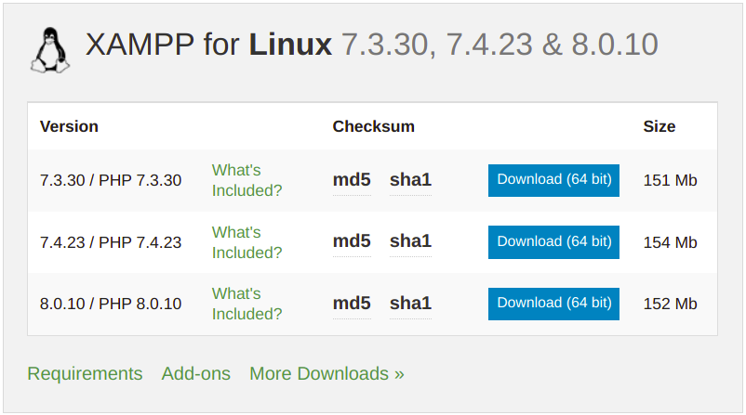

1. **Install –**

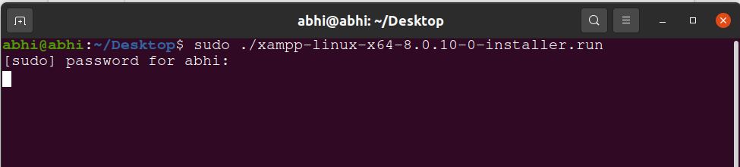

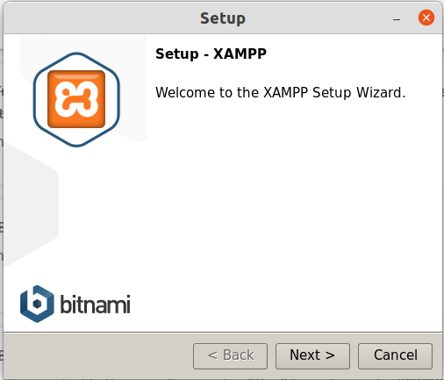

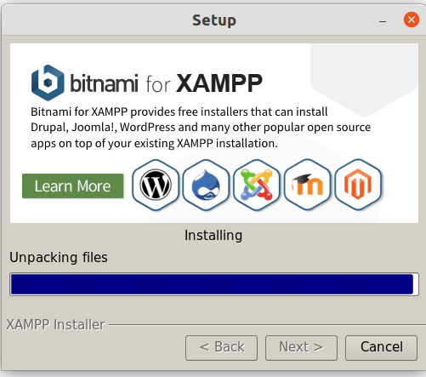

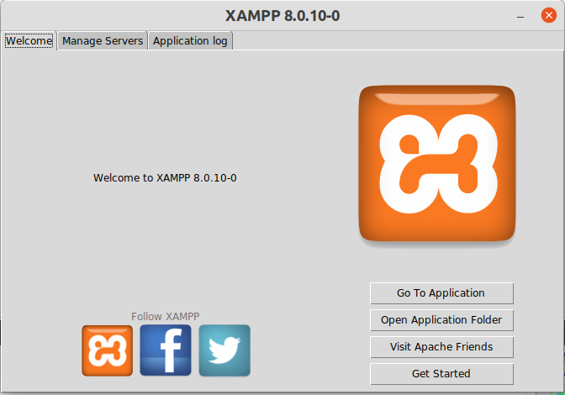

1. **Running Server –**

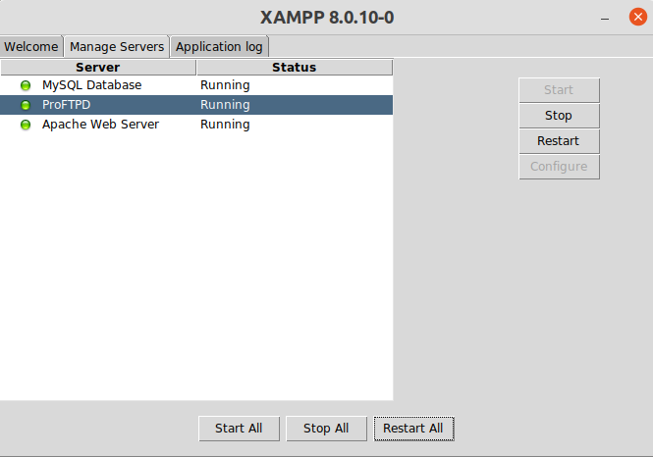

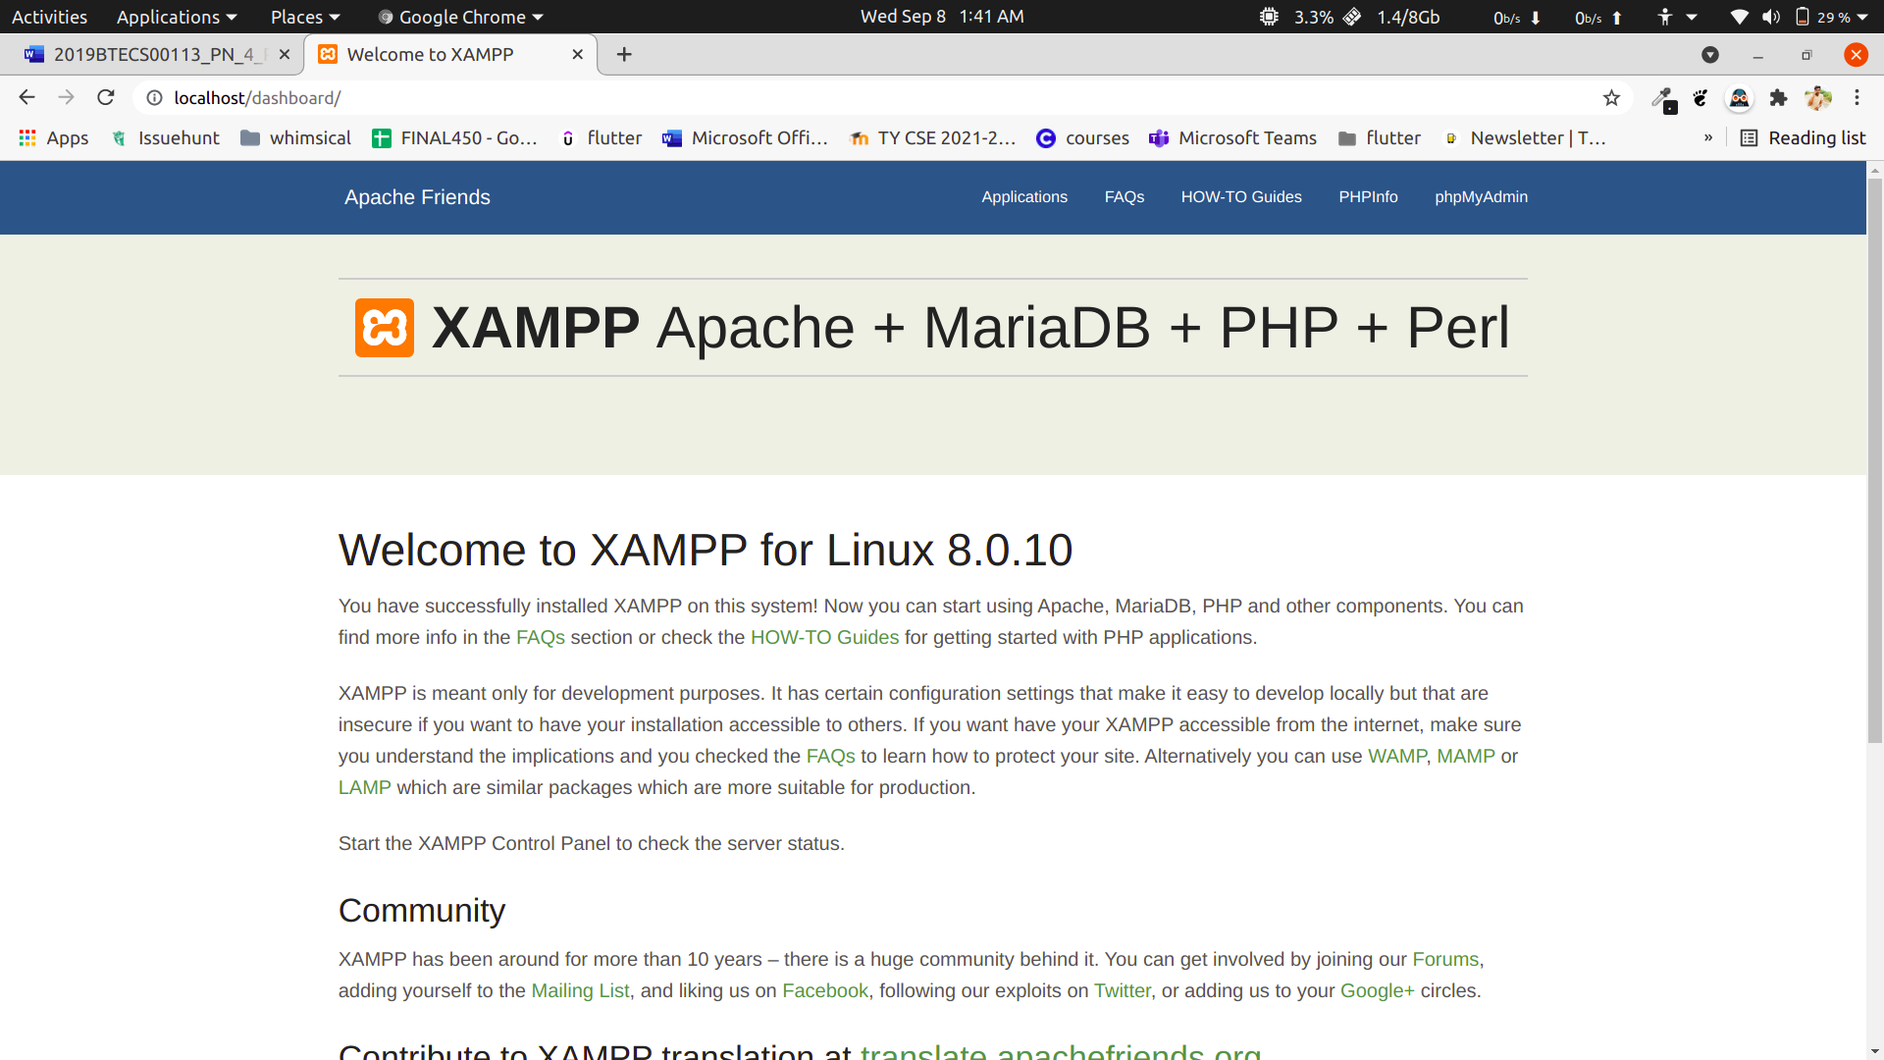

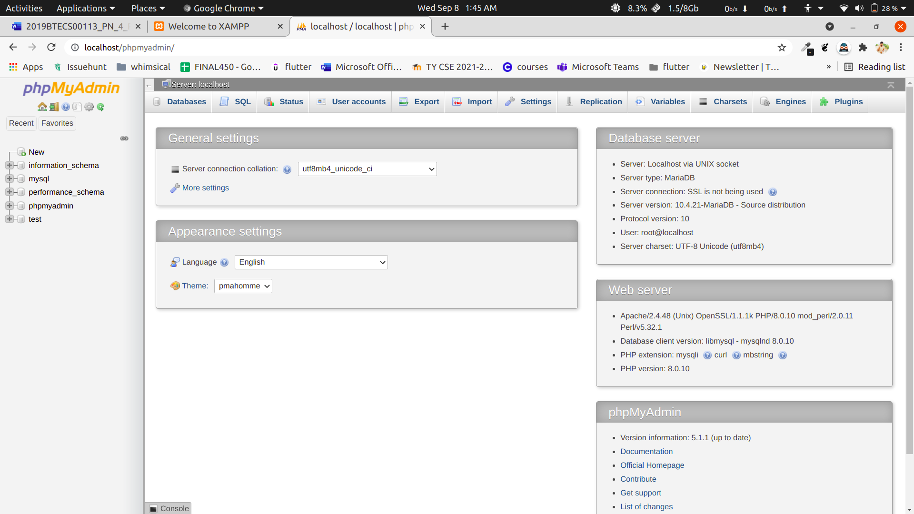

1. **Locate and study its configuration file.**

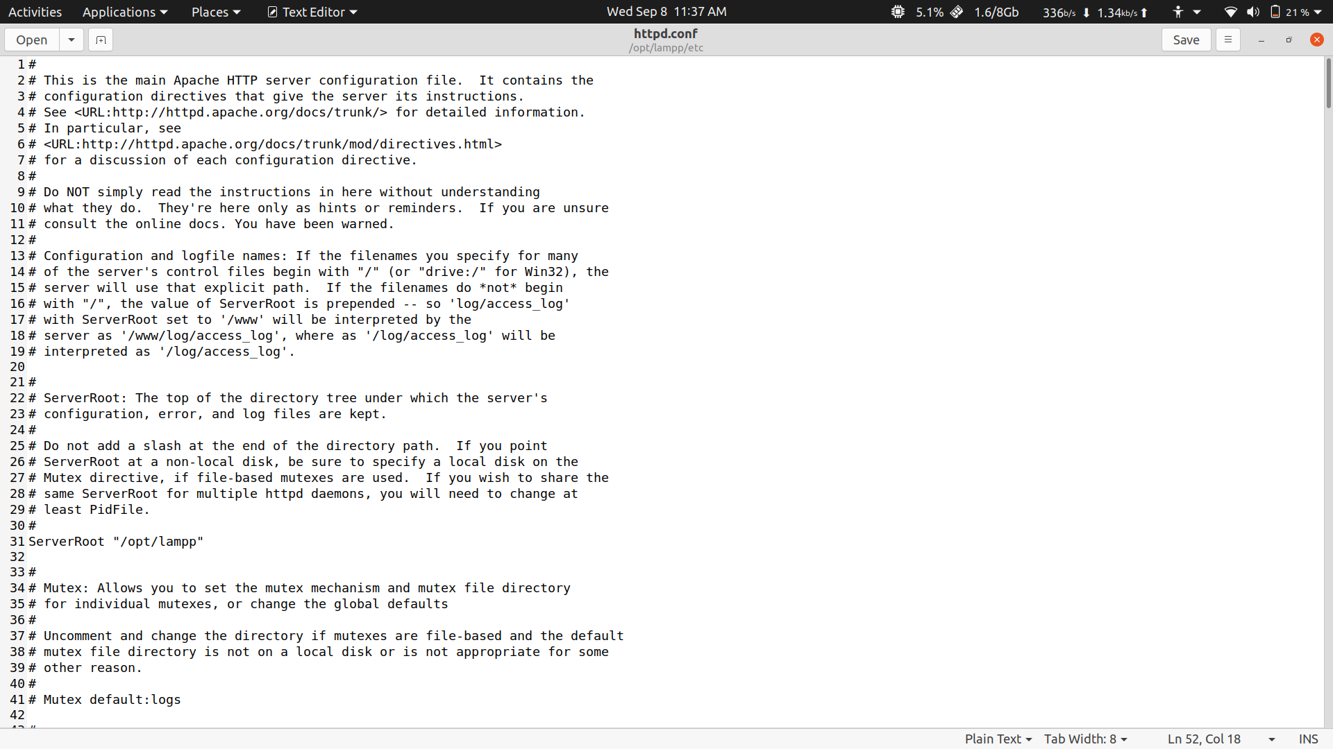

1. **Change the port number in the configuration file to any other valid port number. Rerun the server locally using newly assigned port number.**

**ANS:**

* 1. **Old port number –**

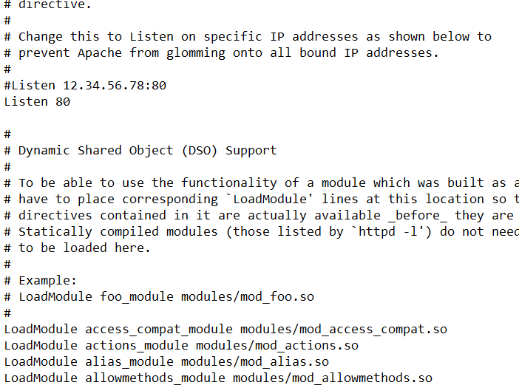

* 1. **New Port Number –**

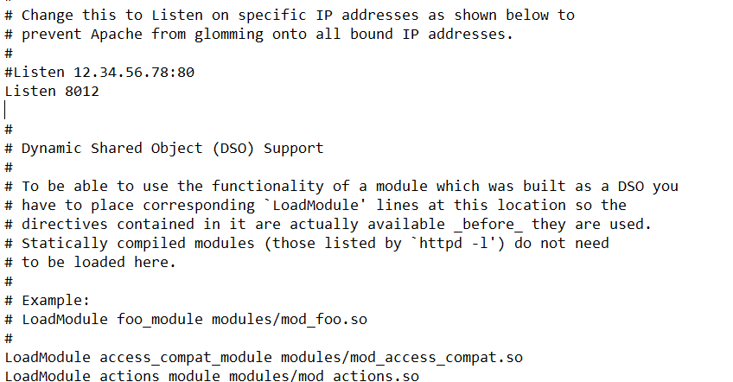

* 1. **Running server with new port number –**

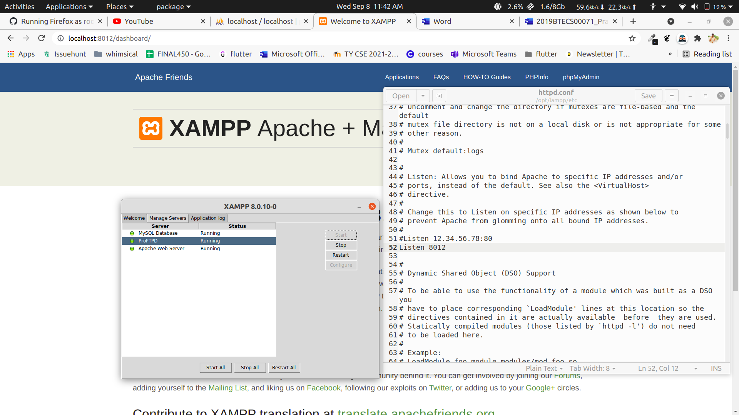

1. **Change the default IP address (127.0.0.1 or localhost) and port number of the server in the configuration file to any other valid IP address and port number. Re-run the server and access it in a network from another machine.**

.ANS:

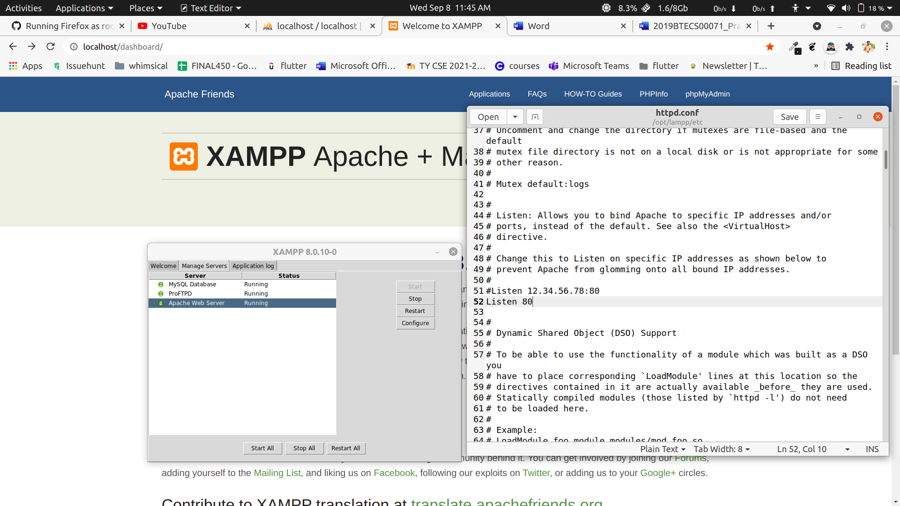

Running Server with Old IP address (localhost)

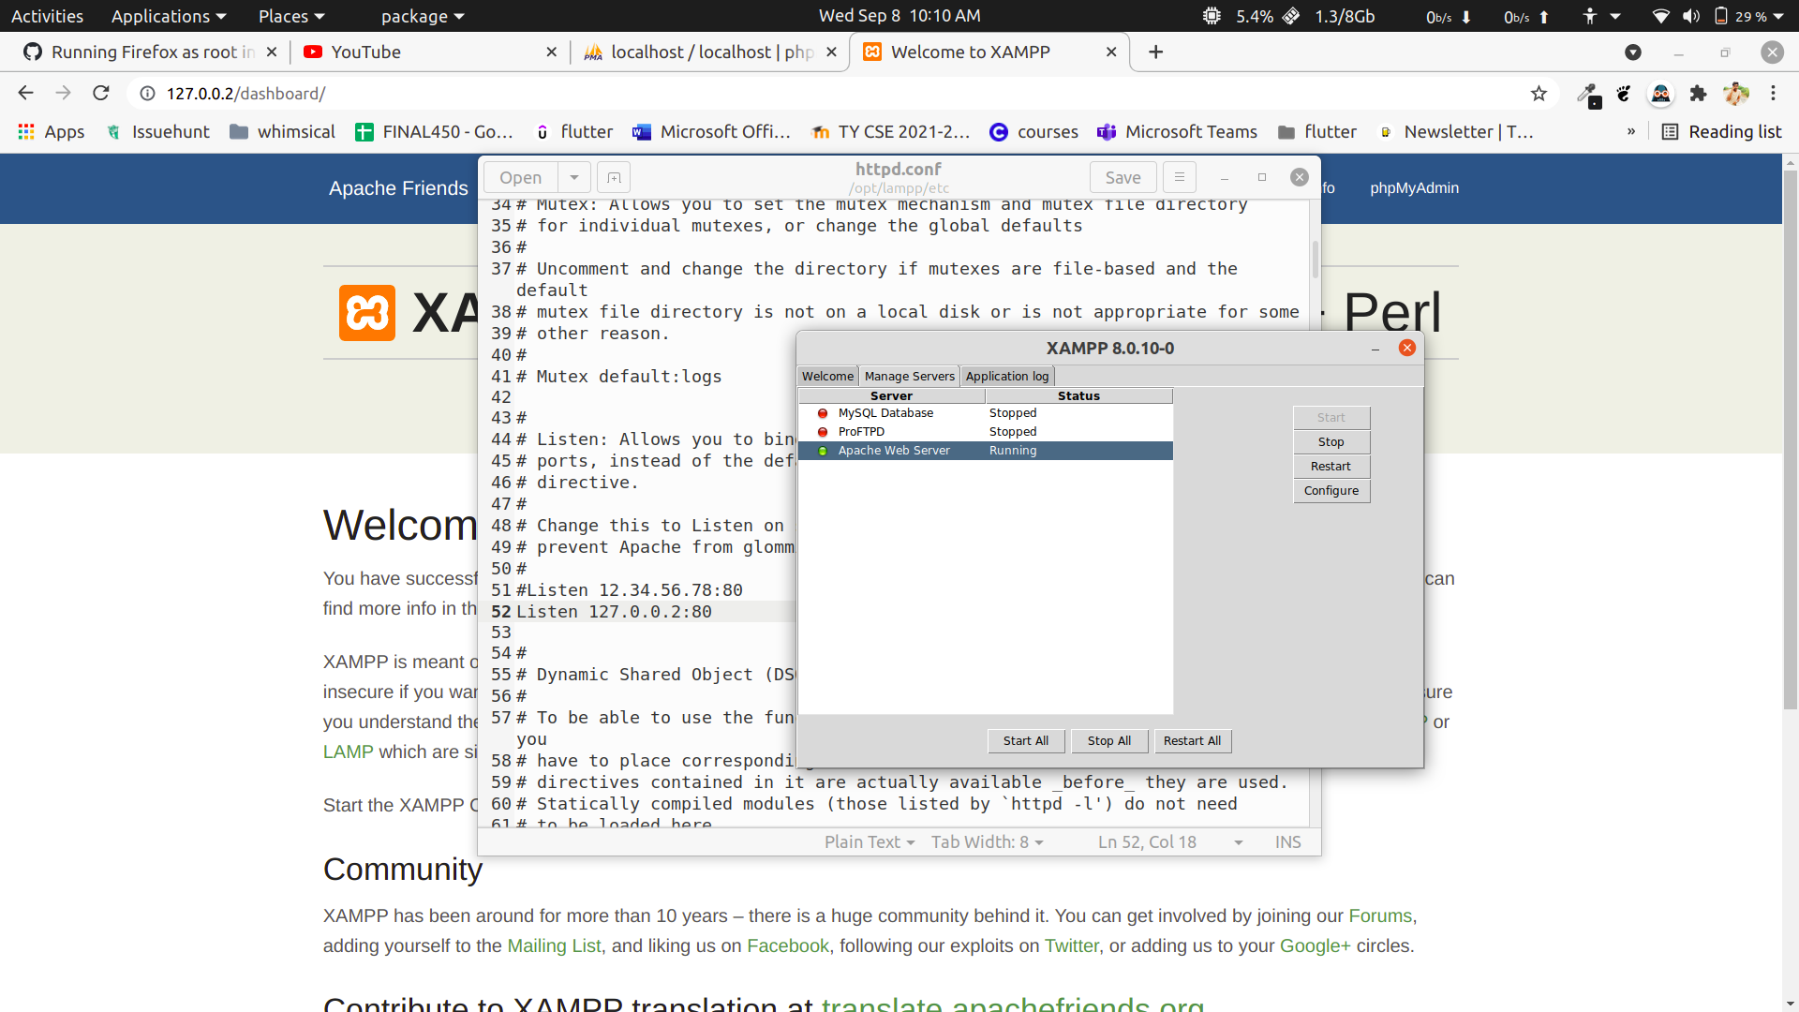

Running Server with New IP address (127.0.0.2 with port 80)